1. 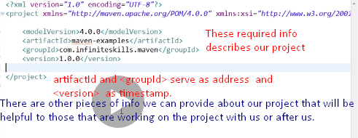
2. **Other info**:
   1. **Operational types of elements:**
      1. **<packaging>:** Kind of artifact we want to generate.
         1. **default:** jar
         2. This is operational piece of info
   2. **Informational types of elements** 
      1. **<name>**: informal name for our project, When talking with another developer.
      2. **<description>**: What our project does.
      3. **<url>**: if we’ve a web site established that contained information about our project we can also specify that.
      4. **<licenses>**:  
         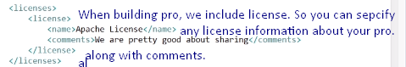
      5. **<organization>, <developers><developer><name></name><email></email></developer></developers>**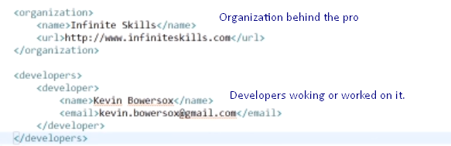
   3. Now you ask who is going to read this xml file to get info about the project?  
      **Good Question**: Maven provides a good feature where we can take this information and build a **web site**.  
      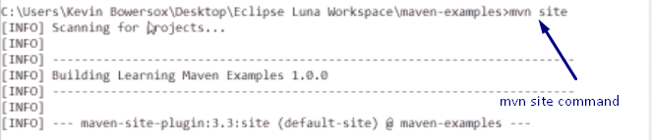  
      **mvn site**: would call the site phase within the **site life cycle**. This would start generating some reports and starts building a web site for us.  
      if this is first time you issue this command, it would go out and grab plug-ins so would take some extra time.
3. 